Town of Cary, North Carolina Budget Analysis

Stephanie Day
Center for Public Administration and Policy, Virginia Polytechnic Institute and State University
PAPA: 6314
Dr. Stephanie Davis
May 7th, 2023

Introduction
Cary, North Carolina, is a town of approximately 176,000 (U.S. Census Bureau, 2022) residents, located in central North Carolina. Cary, North Carolina, has a personal mission to make their budgeting process clear and transparent for their residents. The town has been recognized by the Government Finance Officers Association (GFOA) many times for their excellent financial reporting, “The Government Finance Officers Association of the United States and Canada (GFOA) awarded Cary the Certificate of Achievement for Excellence in Financial Reporting for its ACFR for the fiscal year ended June 30, 2021. This was the thirty-seventh consecutive year that Cary received this award. The Certificate of Achievement recognizes the Cary financial report for voluntarily meeting the highest standards established by experts in government finance. This FY 2022 report was also designed to meet the same standards of excellence in reporting. - Kimberly Branch, CPA, CPA Finance Director” (Town of Cary, 2022)
While the Town of Cary may be awarded for its clear financial reporting, this is not necessarily an indicator of a financially sound organization. Many of the Recommended Budgeting Practices outlined by the GFOA are rooted in planning and government transparency, something Cary clearly excels at, but this organization outlines more indicators that support Cary’s continued financial stability.
History of Organization
The Town of Cary, North Carolina, has roots back to the 1750s and was once called Bradford’s Ordinary. It was officially founded in 1871 when the Seaboard and North Carolina railroads created a railroad junction in the area. The Research Triangle Park, a large group of companies committed to scientific research and growth, was developed in the area during the 1960s. This research hub quickly created new jobs, which turned Cary from a small town to a rapidly growing community. The number of residents nearly tripled in the 1970s, doubled during the 1980s, and doubled again during the 1990s.
Mission, Vision, Values, and Goals
The Town of Cary operates under the following mission statement: “At the Town of Cary, we focus every day on enriching the lives of our citizens by creating an exceptional environment and providing exemplary services that enable our community to thrive and prosper.” (Town of Cary, 2006)
To achieve their mission, the Town of Cary upholds the following values:
- “Our organization exists to serve our citizens. We will be open, ensure access, encourage involvement and be accountable to our citizens.
- Employees are our most important resource. We will attract and retain the best employees possible and invest in their personal and professional growth.
- We will be honest, ethical and diligent. Our actions will comply with local, state and federal laws.
- We will treat everyone with dignity, respect and fairness.
- We will achieve the best results through effective teamwork, strategic partnerships and community participation.
- We will provide outstanding customer service that is polite, friendly and responsive.
- We value creative thinking and innovation. We will continue to be nationally recognized for excellence in local government.
- We value growth that balances desired service levels, economic benefits and continued stability for our community.”
- We are cost conscious. We spend public funds responsibly and effectively to ensure the Town’s short- and long-term financial strength.”
- We are committed to proactive, comprehensive planning to guide the future of our community.
- We will preserve and protect our environment. We will be good stewards of our finite natural resources.” (Town of Cary, 2006)

Budget Calendar and Milestones
Cary operates under a continuous budget process where base and daily operating costs are considered in the annual budget. The Cary Council creates an operating and capital budget for the upcoming year on or before June 30 each year. New budgeting needs are identified by staff throughout the year, and appropriate budgeting recommendations are presented to Council after the close of each quarter. Public comments from those meetings are included in each Council Quarterly Report. Citizens of Cary are invited and encouraged to share their thoughts and priorities through budget public hearings held during their regular meetings in May and June. They also provide resources through Cary’s website to reach out no matter the time of year through social media, phone, or email.
Size and Structure of Organization
During 2013 and 2014, a full organizational restructuring was implemented by the Town of Cary local government, the largest restructuring in 20 years, creating new departments and jobs. The Town of Cary now employs over a thousand employees in more than 275 positions across fourteen departments, as displayed in Table 1:
Table 1
Town of Cary Organization Chart
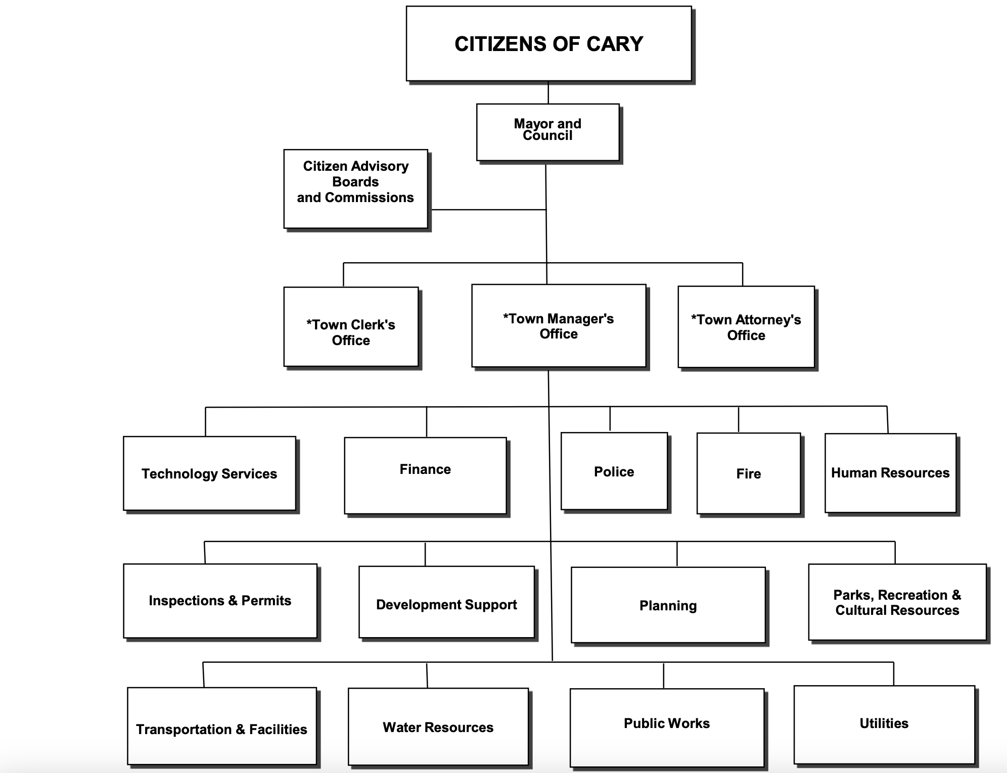
(Town of Cary, 2013)

Revenue Analysis
General Overview
Cary, North Carolina, has many sources of revenue, including property tax, sales tax, the utility fund, general capital sources, and utility capital sources. Some of these revenues have had such successful years that Cary was able to reduce the property tax rate, despite property taxes consistently showing as their largest source of revenue. Cary has made efforts to improve and diversify other sources of revenue as their demographic changes with time, so that they can continue this upward trend and provide the best possible services and facilities for the people who live there.

Top Five Revenue Sources
Property Tax
At $116,213,255 and 28.4% of the revenue, property taxes are the largest source of revenue for the city (Fiscal Year 2022, p.60). This tax includes both real property (land and buildings) and personal property (vehicles and business equipment). Personal property tax is collected throughout the year and is combined with vehicle ad valorem tax collection through North Carolina’s Tax and Tag program. The property tax rate notably decreased ½ cent over this fiscal year and is now $0.345 per $100 of assessed valuation. The Town of Cary gives three reasons for this. First, sales tax in the local area continued to perform well during the pandemic. Second, because of a slight rise in tax base value of 1.3%, and third, a projected property tax collection rate of 99.7%. Together, these factors offset the half-cent decrease in property tax. This aligns with the city’s people-first vision, stating that “we are committed to asking Cary taxpayers for resources when they are needed and will in turn recommend tax rate decreases when they can be afforded.” (Fiscal Year 2022, p.6). Property tax values in Wake County are revalued every four years; the last revaluation became effective January 1, 2020.
Utility Fund
$83,900,140 of revenue for Cary comes from the Utility Fund. Water and sewer fees make up 96.3% of the Utility Fund revenues (58.5% for sewer, 38.7% for water) (Fiscal Year 2022, p. 202). Cary uses a tiered rate system for water, which they use to estimate revenues for the utility fund. (Fiscal Year 2022, p. 204) The budget includes a $0.50 base rate increase and a 1.5% volumetric rate increase for water/sewer/irrigation services. This increase is estimated to generate approximately $1.7 million more in revenue than the previous year (Fiscal Year 2022, p. 9)

General Capital Sources
27% of the general capital sources revenue comes from $2.9 million in Wake County Transit Tax funds. 21% of this budget comes from $16.7 million in general fund transfers. 20% comes from $15.9 million of general capital reserve fund, and another 20% from $15.7 million of debt. 9% of this budget comes from $7 million in government grants (Town of Cary, p.12). These revenues typically go toward water and sewer projects such as infrastructure replacements, maintenance, and repairs.

Sales Tax
Cary’s local economy continued to perform well during the pandemic, with sales tax collections back to record highs post-pandemic. Cary’s financial department does not feel that federal stimulus dollars are the real reason for this continued success; rather, they state that “Our local economy is rooted in technology and healthcare and continues to excel in the pandemic’s work-from-home environment.” (Fiscal Year 2022, p.6) While preparing for another year of the pandemic, the town of Cary budgeted fiscal year 2021 sales tax revenue at $6.9 million below the budgeted sales tax revenue of fiscal year 2020. Fiscal year 2021 sales tax is estimated at $41.1 million, $11.8 million over fiscal year 2021 budget and $3.4 million (9%) above fiscal year 2020. The Annual Operating Budget states that “The FY 2022 budget sets sales tax revenue at $43.6M, or $2.4 million higher than FY 2021 estimated revenue. Bringing sales tax revenue assumptions back in-line with our strong local economy yields approximately $14.2 million of sales tax revenue in the FY 2022 budget compared to the FY 2021 budget.” (Fiscal Year 2022, p. 7). In total, fiscal year 2022 sales tax revenues are budgeted at $43,560,706 or 6% above fiscal year 2021 estimates. (Fiscal Year 2022, p.90) The fiscal year 2022 budget recognizes the positive trends in sales taxes as the main factor towards Cary’s ability to lower the FY 2022 property tax rate while still maintaining service levels for those who live in Cary.

Utility Capital Sources
Utility capital sources are funded through $18.8 million in utility capital reserve fund balance appropriations. The utility fund provides $13 million and $1 million in municipal partner funding. No new debt is required for future utility capital projects (Fiscal Year 2022, p. 13).

Table 2
Town of Cary Revenue Sources Chart
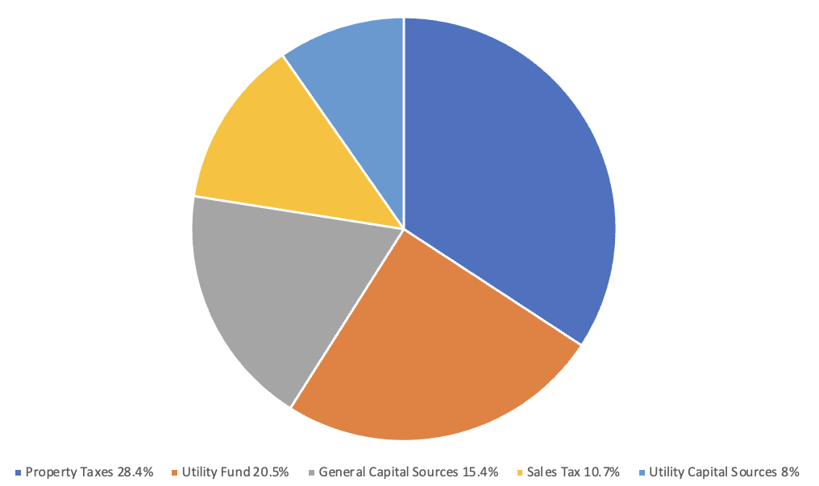
Table 3
Town of Cary Past Revenue Chart
 | Revenue FY 2018 | Revenue FY 2019 | Revenue FY 2020 | Revenue FY 2021 | Revenue FY 2022
Property Tax | $90,981,060 | $93,321,759 | $96,188,865 | $114,260,225 | $116,213,255
Utility Fund | $79,273,398 | $81,049,509 | $83,096,652 | $80,815,018 | $83,900,140
General Capital Sources | $34,488,150 | $40,106,133 | $36,162,063 | $68,496,065 | $62,868,161
Sales Tax | $33,621, 616 | $35,310,265 | $36,622,023 | $29,297,628 | $43,560,706
Utility Capital Sources | $29,532,634 | $42,809,905 | $37,593,775 | $28,235,763 | $32,830,039

Revenue Trends
Cary is a highly desirable area to live in today, in part because of the massive influx of new residents to the area in the 1990s and 2000s due to the success of the Research Triangle Park. While the movement to the area has stalled in the past decade, the consistent maintenance and upkeep have made Cary a high-demand place to live and continue to be its biggest strength and source of revenue. Continuing to invest in inspections, construction, and upkeep of public facilities will assist Cary in continuing to have a good reputation for quality of life and services, which will, in turn, bring in residents and businesses that continue to find the area attractive. This cycle will continue to be a benefit toward Cary’s largest and most stable source of revenue, which will assist Cary in its overall mission of enriching the lives of its citizens.
Because the property tax revenue has been slowing over the years, Cary is already taking steps to increase other sources of revenue, like sales tax, to diversify its revenue sources as their demographic changes, even lowering the property tax this past fiscal year in the process. The town of Cary has also organized its budget so that many of these revenue sources fund expenditures that are related to them, for example, transportation revenue going toward transportation expenditures. This kind of organization within a budget creates stability and helps to prevent overspending, as outlined by the Government Finance Officers Association in “Recommended Budget Practices” (Recommended Budget Practices, p. 30)

Expenditure Analysis
General Overview
The Town of Cary calls upon its values and mission statement, and is committed to providing exceptional facilities, public services, and infrastructure for its citizens, and keeping that infrastructure well-maintained. Infrastructure maintenance continues to be a main priority, and much of the budget focus for expenditures.
The Town of Cary has three financial initiatives for this fiscal year: 1. “Continue migrating operating and capital budget request processes from outdated technology to internally developed systems within Salesforce”, 2. “Continue refining the newly developed general fund financial model and integrate resulting analysis into routine reporting and annual budget documents,” and 3. “Enhance revenue and expenditure analysis in an effort to best monitor, manage, and inform in the evolving COVID-19 economic environment.” (Town of Cary, 2022)

Table 4
Town of Cary Expenditure Chart
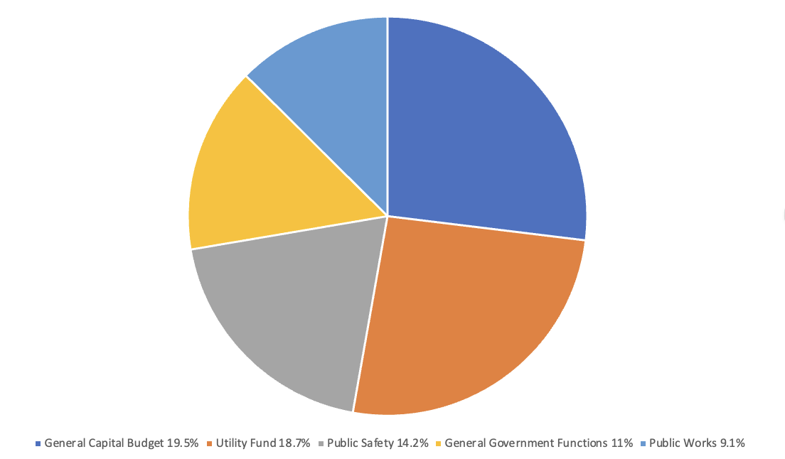

General Capital Budget
The General Capital Budget reflects 19.5% of the total expenditures. The General Capital Budget is the largest category for expenditures. It includes Transportation, Transit, Fire, Parks, Recreation and Cultural Resources, General Government, and Downtown projects. Because maintenance and upkeep are common themes and priorities throughout the budget report, many of the largest highlighted projects include street and sidewalk upkeep and improvements. The general capital budget totals saw a 30% decrease from last year. It is not uncommon for the funds in this category to shift dramatically, due to the potential for large projects to be at different stages from year to year and needing funding accordingly. Also included in the General Capital Budget are projects such as the Americans with Disabilities Act improvements ($1.8 million), historic preservation ($850,000), a solar-ready initiative ($800,000), and housing projects ($300,000) (Town of Cary, p. 11).
Utility Fund
The Utility Fund reflects 18.7% of the total expenditures. Utility Fund expenditures fund the water and sewer system, water projects, and maintenance, such as water plant expansions. The Utility Fund saw a 5.6% decrease in expenditures from last year’s budget, and this decrease is mainly due to a $4 million decrease in funding contributed toward Other Post-Employment Benefits. Much like the General capital budget, the Utility Fund has a focus on service maintenance and upkeep. Maintaining the routine operations costs $51.8 million, using 69% of the budget. The remaining 30% of the Utility Fund budget is used towards paying off debt while the departments transition to fund more of their programs through operating transfers.

Public Safety
Public Safety reflects 14.2% of the total expenditures. The Public Safety Administration and its budget contribute to Police, Fire, and Code Enforcement. This department creates emergency management activities for disasters and other large, planned events. The Public Safety division is also point-of-contact for 911 and other emergency services. Significant fiscal year goals of the Fire Department and the Police Department both involve outreach and collaboration with their respective departments in other nearby cities of Morrisville and Apex, and both also mention continued community outreach. The majority of both the Fire Department and Police Department budgets fund Personnel Services.

Public Works
Public Works departments reflect 9.1% of the total expenditures. There are five Public Works divisions not included in the utility fund. These are the Public Works and Utilities Administration, Facilities Management, Fleet Management, Operations, and Solid Waste, Recycling, and Yard Waste. Facilities Management maintains city buildings and grounds and assists in safety situations regarding roadway obstructions and hazardous tree management. Fleet management is responsible for repairing and maintaining town vehicles and other town equipment. Operations have responsibilities that fall under both the Utility and General Fund expenditures, including traffic markings, stormwater system operations, and maintaining around-the-clock teams for traffic signal maintenance. Solid Waste Management, Recycling, and Yard Waste provides weekly curbside garbage and recycling collection services, bulky item collection, and leaf collection in the fall.
Table 5
Town of Cary Past Expenditure Chart

 | Expenditures FY 2018 | Expenditures FY 2019 | Expenditures FY 2020 | Expenditures FY 2021 | Expenditures FY 2022
General Capital Budget | $39,040,650 | $52,466,469 | $ 37,512,063 | $111,678,075 | $78,196,847
Utility Fund | $69,868,476 | $70,297,055 | $72,927,294 | $79,480,189 | $75,013,869
Public Safety | $49,537,721 | $45,921,204 | $52,607,321 | $54,293,355 | $ 56,711,918
General Government Functions | $25,359,006 | $24,136,390 | $30,503,315 | 36,348,035 | $43,888,361
Public Works | $30,952,946 | $28,925,856 | $33,891,969 | 31,581,616 | $36,452,920

Trends and Expenditure Conclusions
The Town of Cary has gone through a transformation over the past decade from a rapidly growing community to a maturing community. Because of this, many of the resources that were once directed toward growth-related projects (new facilities, roads, schools, etc.) have been redirected toward maintenance and upkeep. While the Town of Cary still receives most of its revenue from property taxes, its property tax revenue has been slowing due to increased cost of property maintenance and decreased growth as its demographic changes. Continuing to budget for and have a focus on maintenance is crucial to their people-first mission, while maintaining the property value and desirable nature of the area keeps that source of revenue from slowing further. The Town of Cary is proactively making changes due to the nature of this slowing property tax trend. The Imagine Cary Community Plan involves shifting Cary’s tax base revenue growth toward commercial and residential redevelopment. Projects such as the Eastern Cary Gateway and Downtown Cary are creating new economic hubs in the area, an example of the newfound expenditure strategy as a reaction to the revenue trends, and for the Town of Cary to maintain financial stability in the future. Because of its successful budgeting practices in the past, Cary can look further ahead and make strategic budgeting changes before the property tax revenue trend becomes a more serious budgeting problem for the local government and the community.
Budget Process
The Town of Cary uses a rolling budget process. The rolling budget process makes it simpler for adjustments to the budget mid-year through quarterly meetings and other collaboration during the fiscal year. Because of this rolling system, budget planning continues year-round. The capital and operating budgets are finalized between January and April. These finalized budget proposals are sent to the Council for their approval in May, and the budget is adopted during the last Council meeting in June. The budget takes effect on July 1st. A chart showing the Town of Cary’s budget schedule in its Annual Operating Budget can be seen in Appendix A.
Cary’s budget process is collaborative. Department directors meet before presenting recommendations to the Town Manager. The FY 2022 budget implemented a newly founded Financial Foundations subcommittee, which comprises department directors across the local government. The Financial Foundations team is responsible for meeting throughout the year to discuss financial issues, so the local government and community can fully utilize the benefits and flexibility of the rolling budget process. While the Financial Foundations team finalizes their budget requests, they compare those requests to Cary’s long-term financial goals, ensuring that the finalized budget is in line with Cary’s values and vision.
When situations arise where the budget needs to be amended during the fiscal year, the department initiating the request submits a Budget Adjustment Request to the Financial Strategy Analysts, the Town Manager, and the Chief Financial Officer. The transfer of funds between departments always requires approval from the City Manager. Once approval is received, the transfer is initiated by the Town Manager, is entered into Cary’s accounting system, and is reported to the Town Council in the next quarterly meeting. Unbudgeted revenues are also reported to the Council during each quarterly meeting.
The rolling budget system allows for more budget flexibility, which serves the Cary community as its demographic continues to change. The multiple perspectives of the Financial Foundations Team also contribute to the success of the rolling budget system, making it department inclusive. This budgeting system includes room for funds that can be used during the fiscal year to address needs as they arise, and systems in place to use those funds if necessary. Perfecting this rolling budget system gives the local government the ability to serve its citizens in ways that would be difficult with a more static system.
CAFR Analysis
Cary’s general budget has a variance of $1,640,608 and an unassigned fund balance of $12,414,568 (Fiscal Year 2022 Annual Comprehensive Financial Report, 2023) The Town of Cary also received a clean unmodified opinion from independent certified public accountants at Cherry Bekaert LLP, stating that the financial statements are presented fairly and are free from misstatement (Annual Comprehensive Financial Report, p.81). While this is a positive sign, Dr. Sheryl Bailey states that auditing is not the only indicator of a financially sound organization (Bailey, 2023). There are other indicators that must be accounted for, many of which can be found in the GFOA’s Recommended Budgeting Practices.
Many of the Recommended Budgeting Practices encourage planning and government transparency, something Cary has excelled at. Good examples of these practices include publishing a comprehensive budget calendar that specifies when budget tasks are to be completed (GFOA, p.38), presenting the budget to be reviewed by stakeholders (GFOA, p. 53), preparing a summary of both the proposed and final budget (GFOA, p. 59), and providing opportunities in the budget process for obtaining stakeholder input (GFOA, p.42). All these recommended budgeting practices are reflected in Cary’s organizational structure, excellent financial reporting, and encouragement of citizen comment and participation, as shown by their recognition from the GFOA.
While commendable, planning and reporting practices are not enough to indicate a strong budget on their own, and a Financial Condition Analysis must be completed for further information. As stated in a lecture by Dr. Bailey, there are no formal rules or unique indicators that are always used in a Financial Condition Analysis, but through consistent comparison, there are some general things to look for. For example, Dr. Bailey states that conservative revenue estimates are an important indicator of a successful budget, a policy Cary has adopted as illustrated by an example in Cary’s Sales Tax revenue section. Conservative estimation of their sales tax revenue allowed for their success in the following year, and through the COVID-19 pandemic.
Another indicator of Cary using recommended budgeting practices is found in its rolling budget model. As outlined in the Recommended Budget Practices, “A government should adjust its policies, plans, programs, and management strategies during the budget period, as appropriate.” (GFOA, p. 69) and “A government should develop and implement a set of procedures that facilitate the review, discussion, modification, and adoption of a proposed budget.” (GFOA, p.31). Cary’s rolling budget process has allowed their government to adopt both practices and be flexible and able to react to changes more quickly than a more static budget calendar.
Recommended Budget Practices also states that “A government should adopt a policy that encourages a diversity of revenue sources.” (GFOA, p.25). As Cary has been seeing demographic changes, it has also been looking towards commerce and sales tax as important future revenue streams, rather than continuing to rely upon property tax, even emphasizing building economic hubs in the Imagine Cary Community Plan. The Imagine Cay Community Plan is a forty-year plan that also fulfills the GFOA recommendations of assessing the long-term financial implications of current and proposed policies (GFOA, p.43), and developing a “capital improvement plan that identifies its priorities and time frame for undertaking capital projects and provides a financing plan for those projects.” (GFOA, p. 52). Cary is also in the practice of matching recurring revenue sources to recurring expenditures as suggested in Recommended Budgeting Practices (GFOA, p.21), for example, Cary’s transportation revenues funding transportation expenditures.
Appendix A
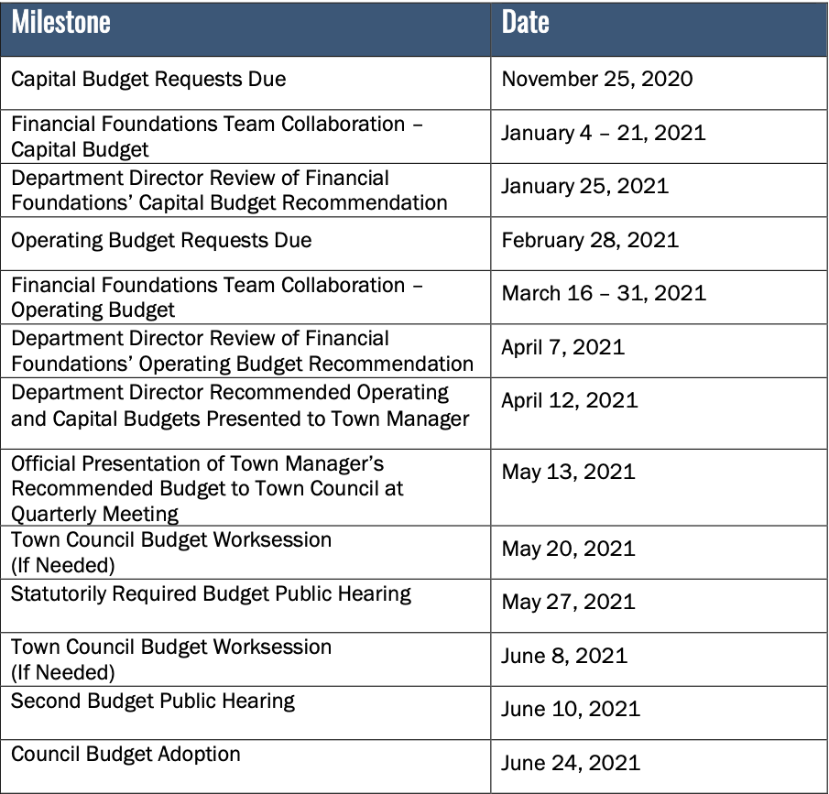
(Town of Cary, 2022)

Bibliography:
“Town of Cary.” Looking Back, https://www.townofcary.org/recreation-enjoyment/about-cary/looking-back.
“Town of Cary.” Mission & Values, https://www.townofcary.org/recreation-enjoyment/about-cary/mission-values, 2006)
“Town of Cary.” Budget Development, https://www.townofcary.org/services-publications/plans-publications-reports/budget/budget-development.
“Town of Cary.” Organizational Restructuring, https://www.townofcary.org/connect-engage/town-departments-offices/organizational-restructuring.
“Town of Cary.” Human Resources Department, https://www.townofcary.org/connect-engage/town-departments-offices/human-resources-department.
Town of Cary, North Carolina. (2022). Fiscal Year 2022. Town of Cary. https://www.carync.gov/home/showdocument?id=27329

Town of Cary, North Carolina. (2021). Fiscal Year 2021 Annual Operating Budget. Town of Cary. https://www.carync.gov/home/showdocument?id=25221

Town of Cary, North Carolina. (2020). Annual Operating Budget Fiscal Year 2020. Town of Cary. https://www.carync.gov/home/showpublisheddocument/23033/637067344794470000

Town of Cary, North Carolina. (2019). Fiscal Year 2019 Annual Operating Budget. Town of Cary. https://www.carync.gov/home/showpublisheddocument/21186/636755434855330000

Town of Cary, North Carolina. (2018). Fiscal Year 2018 Adopted Annual Operating Budget. Town of Cary. https://www.carync.gov/home/showpublisheddocument/17831/636377797286670000
Town of Cary, North Carolina. (2022). Fiscal Year 2022 Annual Comprehensive Financial Report. https://www.carync.gov/home/showpublisheddocument/29536/638088126914800000

GFOA. (1998). Recommended Budget Practices. https://gfoaorg.cdn.prismic.io/gfoaorg/e4534548-fa06-47ad-9cc8-5f37e6e2f21e_RecommendedBudgetPractices.pdf

Bailey, S. (2023, March 2). VIRGINIA’S BUDGET
FUNDAMENTALS [Powerpoint Slides] https://canvas.vt.edu/courses/168531/files/28404842?wrap=1

Bailey, S. (2023, April 4). PUBLIC BUDGETING PROCESSES
AND THEIR POLICY IMPLICATIONS [Powerpoint Slides] https://canvas.vt.edu/courses/168531/files/28404838?wrap=1

Romanello, A. (2023, March 30) PAPA6314 – Public Budgeting and its Policy
Implications [Powerpoint Slides] https://canvas.vt.edu/courses/168531/files/28401687?wrap=1
U.S. Census Bureau Quickfacts: Cary Town, North Carolina. https://www.census.gov/quickfacts/fact/table/carytownnorthcarolina/PST045221.

