Stephanie Day
May 4th, 2024
Education Expenditures and Tax Revenue
Background Information:
This regression analysis examines the relationship between government expenditures and total revenue and seeks to find which government expenditures correlate to more affluent communities, therefore leading to more tax revenue and higher budgets for those states.
Not every government program or expenditure is meant to create a return on investment. A government is not a business that is only concerned with the bottom line. The government provides certain services to its citizens, and some of those operate at a loss. Some state and local governments struggle more financially than others, and information from this analysis may create strategies and best practices as to where limited resources can best be used when a government is focused on increasing revenue. Research of this kind will be of interest to governments focusing on increasing revenue through those tax dollars.
Hypothesis to be Tested
For this regression analysis, Total Revenue is selected as the dependent variable, with Education Expenditures as the main independent variable of interest. Education Expenditures was selected as the variable of interest not only because of the potential for return on investment but also because of the palatability of increasing education expenditures as a future policy option. Research has shown that more educated tax bases create better opportunities for their citizens. This analysis is interested in learning if putting government resources toward education also correlates with more affluent tax bases. My hypothesis is “There is an association between education expenditures and total government revenue”, and the null hypothesis is “There is no association between education expenditures and total government revenue”. It is expected that there is a positive association between these two variables.
Description of Data Sample
Data for this study was retrieved from The Urban Institute’s State and Local financial data. This organization provides state and local public finance data, primarily from the US Census Bureau. The Urban Institute’s datasets include information such as state and local revenue, spending, and debt from 1977 through 2021. All 50 states were used for the geographic area of this study. Data was retrieved in “dollars per capita” when selecting a unit of measurement.
Results of Analysis/Evaluation of Hypothesis
To begin the regression, I created a scattergram to determine the direction of any potential association between the two variables of interest, and learned that the correlation is a positive correlation between the two variables for both 2019 and 2021. Correlation coefficients were also run for these variables, with a correlation coefficient of .7551 for 2019 and .7080 for 2021. Both values suggest a strong correlation.
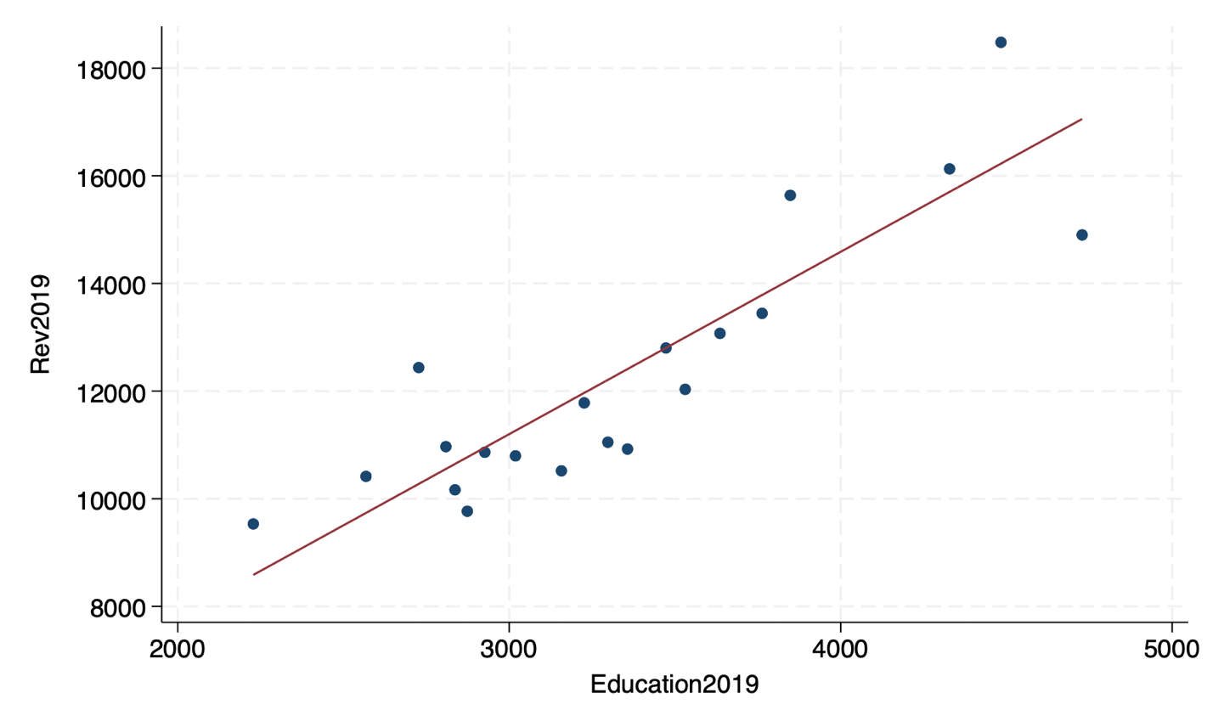
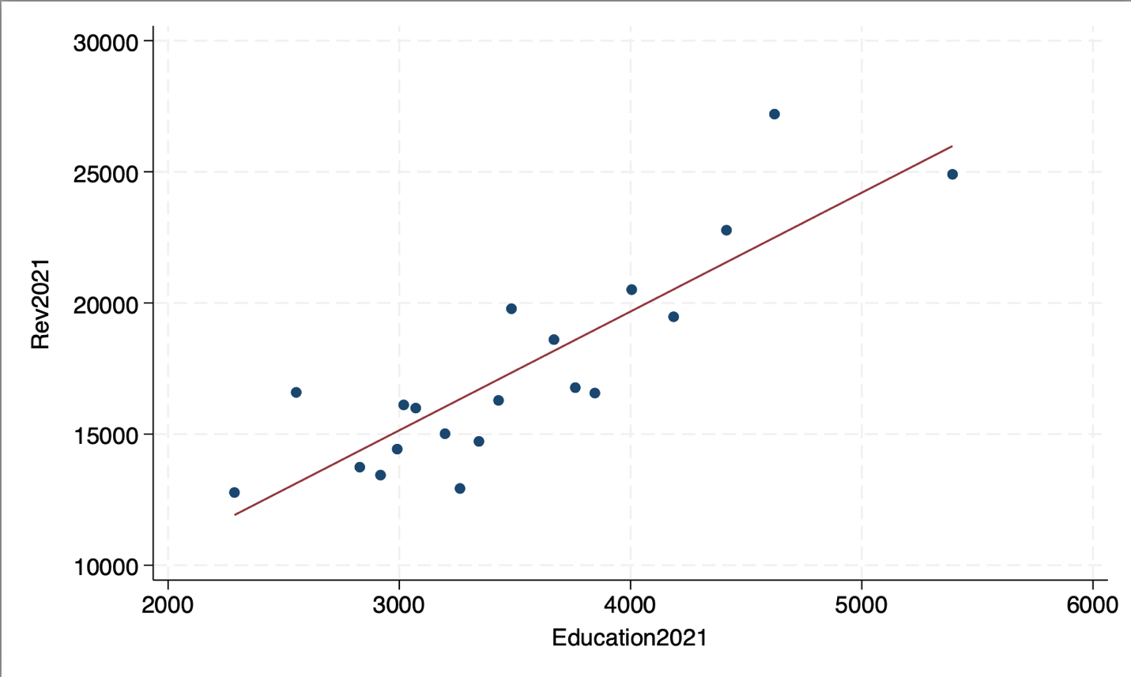
I ran a bivariate regression with total revenue as the dependent variable, and educational spending as the independent variable for both 2019 and 2021 data, and was given the following outputs:
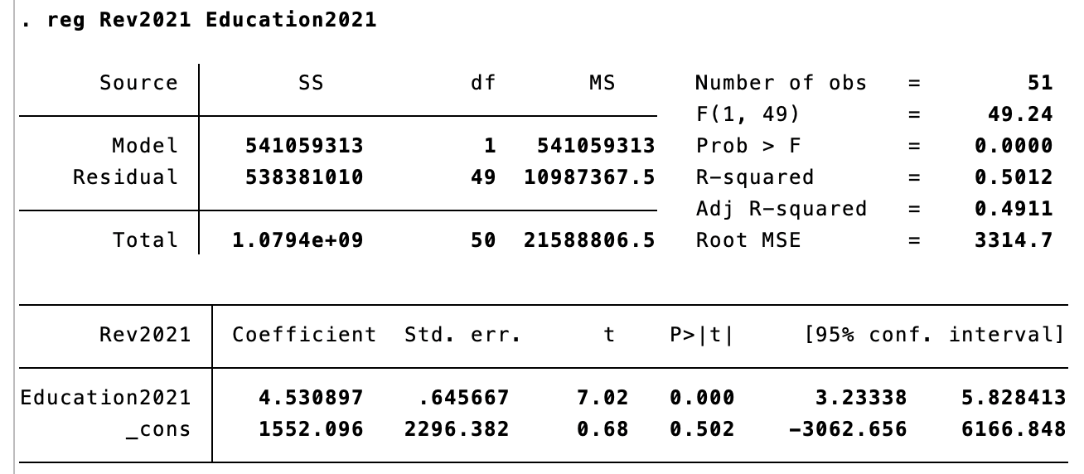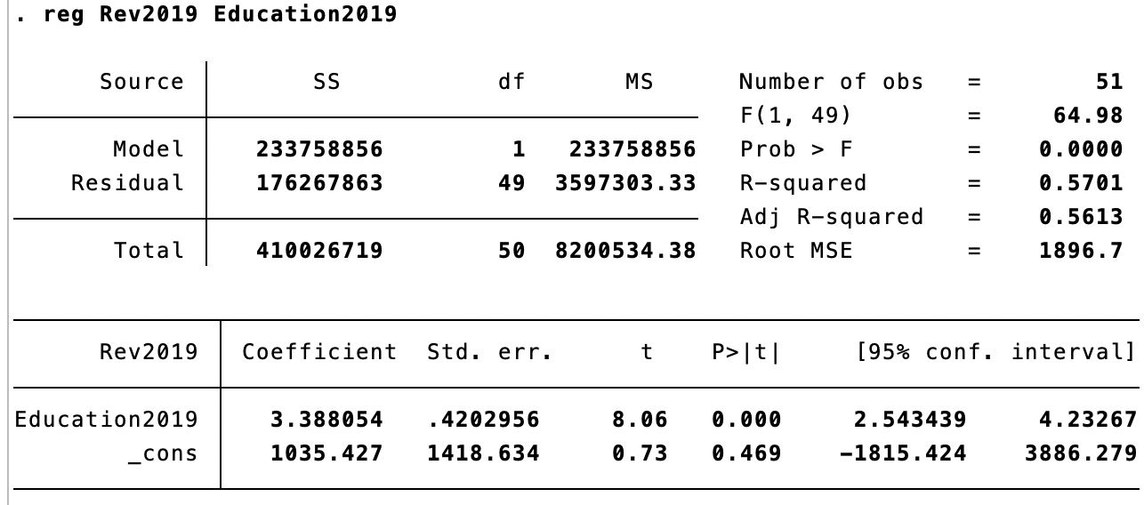
For 2019, the slope coefficient is 3.39, meaning that for each $1 increase per capita in educational spending, there is an associated $3.39 increase per capita in total revenue. The p-value is less than .05, rejecting the null hypothesis in favor of the alternative hypothesis at the 95% confidence level. We can be 95% sure that a $1 increase per capita spent on education is associated with an increase of between $2.54 and $4.23 in total revenue. The constant is 1035.45, showing that if educational spending were at $0 per capita, then total revenue would be at $1035.45 per capita. The r-squared value is 0.5701, showing that educational spending per capita accounts for 57% of the total variance in total revenue per capita.
The 2021 slope coefficient is 4.53. This means for each $1 increase per capita in educational spending, there is an associated $4.53 increase per capita in total revenue. The p-value is less than .05, rejecting the null hypothesis in favor of the alternative hypothesis at the 95% confidence level. We can be 95% sure that a $1 increase per capita spent on education is associated with an increase of between $3.23 and $5.82 in total revenue. The constant is 1552.10, showing that if educational spending were at $0 per capita, then total revenue would be at $1552.10 per capita. The r-squared value is 0.5012, showing that educational spending accounts for 50% of the variance in total revenue.
Comparing the 2019 and 2021 bivariate regressions, the slope coefficient increased, indicating an increase in total revenue received per dollar spent on education. However, the r-squared value dropped seven percentage points from .57 to .50. The percentage of variance in total revenue per capita that can be explained by educational spending decreased from 57% in 2019 to 50% in 2021.
I then completed a multiple regression including expenditures regarding Education, Building, Libraries, Parks and Recreation, Police, and Welfare. The following outputs were given: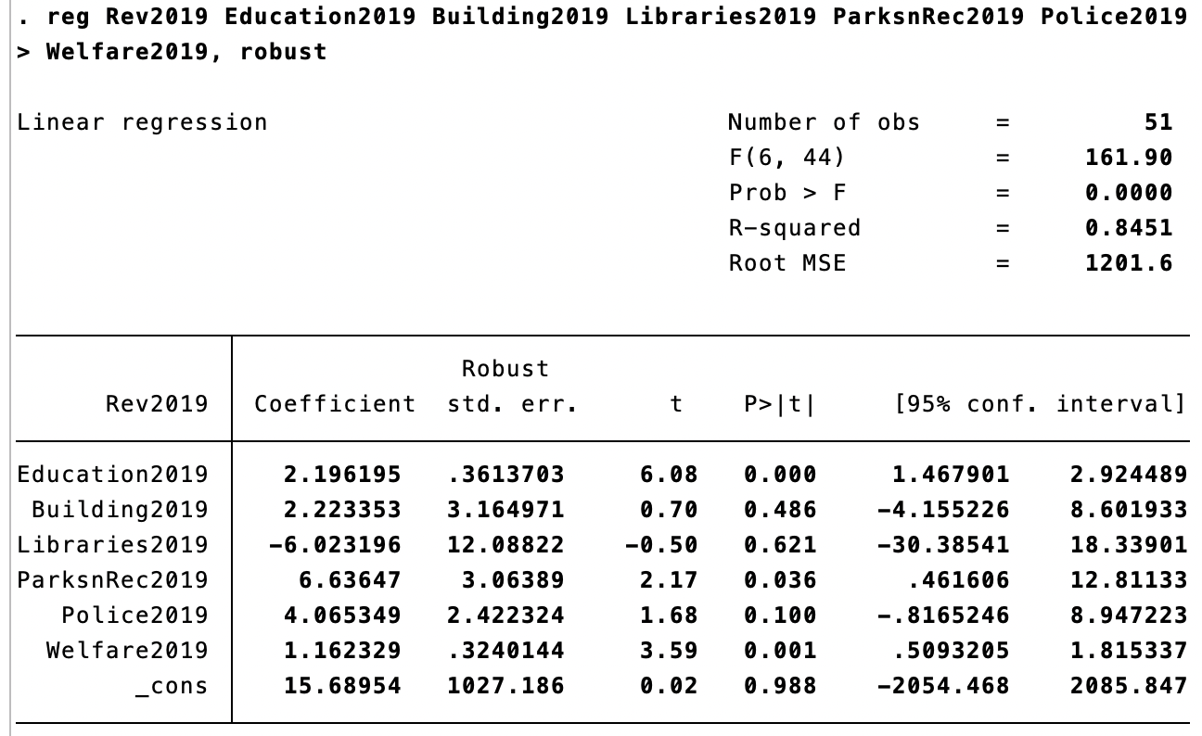
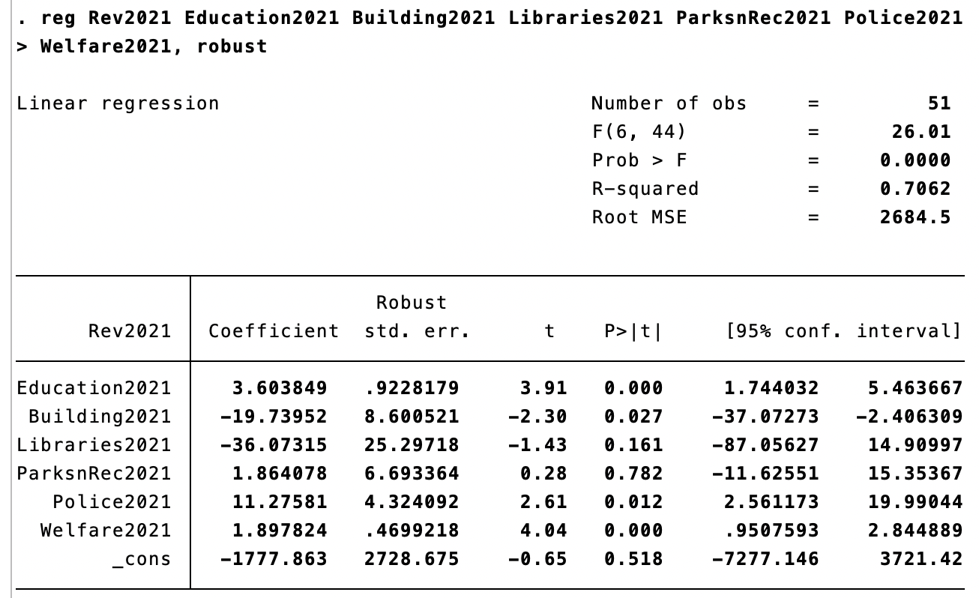In 2019, education’s slope coefficient of 2.19 shows a positive relationship to total revenue. Every $1 increase per capita spent on education is associated with a $2.19 increase in total revenue per capita, holding all else constant. Its p-value is less than .05, showing that it is statistically significant, rejecting the null hypothesis at the 95% confidence level that there is no association between education expenditures per capita and total government revenue per capita.
The building variable in 2019 has a slope coefficient of 2.22, showing a positive relationship to total revenue. For every $1 increase spent on building per capita, there is a $2.22 increase in total revenue per capita, holding all else constant. However, because its p-value is 0.486, it is not statistically significant. I am unable to reject the null hypothesis at the 95% confidence level that there is no association between building expenditures and total government revenue per capita.
The libraries variable in 2019 has a slope coefficient of -6.02, showing a negative relationship to total revenue. Every $1 increase per capita spent on libraries is associated with a $6.02 decrease in total revenue per capita, holding all else constant. However, its p-value is 0.621, so it is not statistically significant. I am unable to reject the null hypothesis at the 95% confidence level that there is no association between library expenditures and total government revenue.
The Parks and Recreation variable in 2019 has a slope coefficient of 6.63, showing a positive relationship to total revenue. For every $1 increase spent on parks and recreation per capita, there is a $6.63 increase in total government revenue per capita, holding all else constant. The associated p-value is 0.36, making the variable of parks and recreation statistically significant, and rejecting the null hypothesis at the 95% confidence level that there is no association between parks and recreation expenditures and total government revenue.
The police variable in 2019 has a slope coefficient of 4.06, showing a positive relationship to total revenue. For every $1 increase spent on police per capita, there is an associated $4.06 increase in total government revenue per capita, holding all else constant. The p-value associated with this variable is 0.1, making it statistically insignificant. I am unable to reject the null hypothesis at the 95% confidence level that there is no relationship between police expenditures and total government revenue.
The welfare variable in 2019 has a slope coefficient of 1.16, showing a positive relationship to total revenue. For every $1 increase per capita spent on welfare, there is a $1.16 increase in total government revenue per capita, holding all else constant. The associated p-value is 0.001, making this variable statistically significant, rejecting the null hypothesis at the 95% confidence level that there is no association between welfare expenditures and total government revenue.
The r-squared value associated with the 2019 regression is .8451, showing that these collected variables explain 84% of the variance in total government revenue per capita. The 2019 constant is 15.68, showing that if government spending were $0 across all these variables, the total government revenue per capita would be $15.68. The 2019 values that had statistical significance are Education, Parks and Recreation, and Welfare.
The 2021 education variable has a slope coefficient of 3.60, showing a positive relationship to total revenue. For every $1 increase per capita spent on education, there is an associated $3.60 increase in total revenue per capita, holding all else constant. The associated p-value is less than .05, showing statistical significance and rejecting the null hypothesis at the 95% confidence level that education expenditures have no association with total revenue.
The building variable in 2021 had a slope coefficient of -19.73, showing a negative relationship to total revenue. For every $1 increase per capita spent on building, there is an associated $19.73 decrease in total revenue per capita, holding all else constant. The associated p-value is 0.027, showing statistical significance and rejecting the null hypothesis at the 95% confidence level that building expenditures have no association with total government revenue.
The libraries variable in 2021 has a slope coefficient of -36.07, showing a negative relationship to total revenue. For every $1 increase per capita spent on libraries, there is an associated $36.07 decrease in total revenue per capita, holding all else constant. However, the associated p-value for this variable is 0.161, showing that it is statistically insignificant. I am unable to reject the null hypothesis at the 95% confidence level that library expenditures have no association with total government revenue.
The parks and recreation variable in 2021 has a slope coefficient of 1.86, showing a positive relationship to total revenue. For every $1 increase per capita spent on parks and recreation, there is an associated $1.86 increase in total revenue per capita, holding all else constant. However, the associated p-value is 0.782, making it statistically insignificant. I am unable to reject the null hypothesis at the 95% confidence level that parks and recreation expenditures have no association with total government revenues.
The police variable in 2021 has a slope coefficient of 11.27, showing a positive relationship to total revenue. For every $1 increase per capita spent on police, there is an associated $11.27 increase in total revenue per capita, holding all else constant. The associated p-value for this variable is 0.012, making it statistically significant, rejecting the null hypothesis at the 95% confidence level that police spending has no association with total revenue.
The 2021 welfare variable has a slope coefficient of 1.89, showing a positive relationship to total government revenue. Every $1 increase per capita spent on welfare is associated with a $1.89 increase in total revenue per capita, holding all else constant. The associated p-value is below 0.05, making it statistically significant, rejecting the null hypothesis at the 95% confidence level that welfare expenditures have no association with total revenue.
The r-squared value associated with the 2021 regression is .7062, showing that these collected variables explain 70% of the variance in total government revenue per capita. The 2021 constant is -1777.86, showing that if government spending was $0 across all these variables, the total government revenue per capita would be -$1777.86. The 2021 regression shows more variables that are statistically significant than the 2019 regression, including Education, Building, Police, and Welfare.
Policy Implications/Limitations:
The most recent data was collected in 2021, so changes in government spending and habits during the pandemic need to be considered. 2019 was run to view trends in a non-pandemic year, but running the data for post-pandemic years, when that data becomes available, would have the most impact because of the world economic changes brought by the pandemic.
Conclusion:
Comparing these two regressions shows how spending priorities and habits by individuals and governments during the pandemic impacted these outputs. The only two variables that remained statistically significant before and during the pandemic and had a positive correlation to total revenue were the variables of education expenditures and welfare expenditures. Both expenditures are potentially safe places to use resources for a government that is going through financial difficulty and is still looking to see a return on investment from government programs.
Some state and local governments struggle more financially than others and using these regression comparisons to know which expenditures are going to bring a return on investment in a statistically significant way, even in times of financial difficulty like the COVID-19 pandemic, can help governments make more educated decisions about where to put the resources they have.

